**KIVA Loans - Comparing Puerto Rico, Costa Rica, & Colombia**

**Business Question**

Is there a difference in the loan amounts for a crowdsourced microlending organization (KIVA) between the countries Puerto Rico, Costa Rica, and Colombia?

**Boxplot Graphic Exploring Business Question**

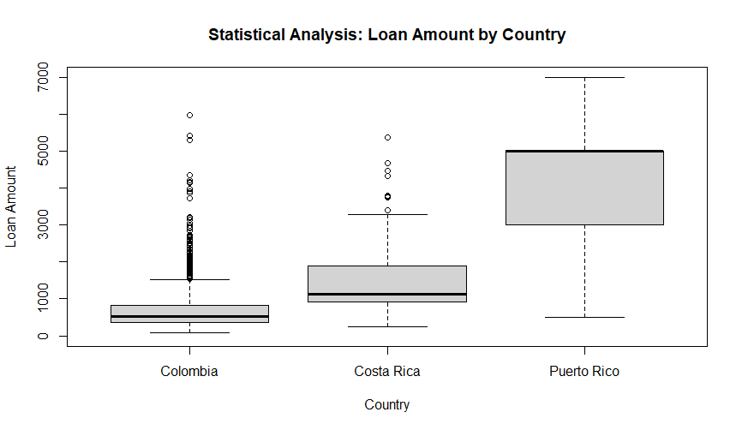

*Based on the boxplot above, Colombia, Costa Rica, and Puerto Rico seem to all receive different loan amounts for KIVA. Colombia seems to receive the lowest loan amounts from KIVA loans while Puerto Rico seems to receive the highest loan amounts from KIVA. Furthermore, Colombia and Costa Rica have a small number of outliers; however, given such a massive sample size, we can proceed with our analysis.

**One Way ANOVA Test**

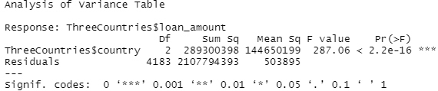

* **Parameters**: **µi** = mean salary for Countryi
  + **µ1**= Colombia, **µ2** = Costa Rica, **µ3**= Puerto Rico
* **Null Hypothesis (Ho)**: µ1 = µ2 = µ3
* **Alternative Hypothesis (HA)**: At least one of the population means is different.
* **Assumptions of the model**: The residuals are random and independent, have the same variability in each group, and are normally distributed (other than the few outliers).
* **Test Statistic**: 287.06
* **P-value**: < 0.0001
* **Conclusion**: Reject H0. Given a large test statistic which is much larger than one, along with a p-value of nearly zero, we have evidence supporting the alternative hypothesis.

**Kruskal Wallace Test**



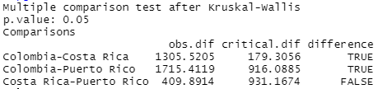

* **Null Hypothesis (Ho)**: Θ1 = Θ2 = Θ3
* **Alternative Hypothesis (HA)**: At least two of Θi are different from the rest.
* **Assumptions:** All possible assignments of loans amounts to countries are randomly assigned and the countries are independent of one another.
* **Chi-squared:** 322.28
* **P-value:** < 0.0001
* **Conclusion:** Reject H0. Based on the extremely low p-value above, we are able to determine that there is a significant difference in the median loan amounts between Colombia-Costa Rica and between Colombia-Puerto Rico. We can also safely determine that there is no significant difference of the median loan amounts between Costa Rica-Puerto Rico.

**One-Way ANOVA Test vs. Kruskal-Wallis Test**

* The data set compares KIVA loans in three different countries: Costa Rica, Colombia, and Puerto Rico. Given the presence of heavy skew and outliers present in the data, a Kruskal-Wallis test seems most appropriate for the data set. Ideally, with one-way ANOVA tests, we want to minimize the presence of outliers in the data. As a result, the Kruskal Wallace is a non-parametric test enabling us to draw optimal conclusions based on three different groups.

**RStudio Code**

**##Installation of tideverse.**

* install.packages("tidyverse")
* library(tidyverse)

**##Filtering Puerto Rico, Costa Rica, and Colombia from the Kiva_Sample data.**

**##Naming filtered data “ThreeCountries”.**

* ThreeCountries<-filter(Kiva_Sample,country=="Puerto Rico"|country=="Costa Rica"|country=="Colombia")

**##Creating Boxplot Graphic Exploring Business Question (Page 1) from the three chosen countries filtered in the previous step.**

**## The range is limited to $7,000, the axes are both labeled, and the title is displayed at the top of the boxplot.**

* boxplot(ThreeCountries$loan_amount~ThreeCountries$country,ylim=range(0,7000),xlab="Country",ylab="Loan Amount",main="Statistical Analysis: Loan Amount by Country")

**##Assigning “ThreeC” to the Analysis of Variance.**

**##Conducting One-Way ANOVA Test (Page 1) based on loan amount by country.**

* ThreeC<-aov(ThreeCountries$loan_amount~ThreeCountries$country)
* anova(ThreeC)

**##Using R to calculate the p-value given the F test statistic.**

* pf(287.1,2,4183,lower.tail=FALSE)

##**Conducting a Kruskal-Wallis Test (Page 2) based on loan amount by country.**

* kruskal.test(ThreeCountries$loan_amount~ThreeCountries$country)

**##Conducting Multiple Comparisons using PGIRMESS (Page 2) to determine significant differences between the three different groups.**

* pgirmess::kruskalmc(ThreeCountries$loan_amount~ThreeCountries$country)